FILE: 0000.doc

=========
=========
=== A === one-off setup
=========
=========
(1)
copy the usertracker folder into resinXXX\webapps
(not into webapps\ROOT)

(2)
create the MySQL database - run the SQL commands in file

userTracker_v1.1\userTracking\db\user_tracking.txt

=========
=========
=== B === organise for new website to track
=========
=========

(1)
delete folder "website"

(2)
copy the website folder you wish to test into the userTracker folder

(3)
rename this website "website"

(4)
copy any beans / java classes into the userTracker_vxx\WEB-INF\classes folder

(5)
run the Java pre-process in folder
\userTracker_vxx\userTracking\javaPreProcess\

(this creates a version of your website in folder "modifiedWebsite"
- it makes all pages JSP and adds the user tracking code to each file)

(5a) WINDOWS users
run the BAT file in
\aa______preProcess_website.bat

(5b) other users
execute the Java file "PreProcess.java" in this folder

you should see status messages appear as you run the file
(you might want to check through to ensure there are no ERROR messages
- this is prototype software ...)

NOTE
Feel free to explore the Java source code for the pre-processor – it is an example of a non-trivial Java program, although it has been written in a simple, rather than efficient way, so should be reasonably straightforward to understand
=========
=========
=== C === run user tracker for copied website
=========
=========

(1)
run the MySQL server

(2)
run Resin

(3)
visit the index page in
\userTracker_vxx\

HINT - I recommend you BOOKMARK this page
so it is easy to return to

this will ask you to enter a username and task number

you can also view the list of user logs stored to date

(4)
having logged in your test user, let them try to complete the task you have set them

(5)
you should now have a set of logs for this user/task in the DB
- this data should form part of your website evaluation evidence

HINT
if the user got stuck / required any assistance then you may with to add a note to the appropriate record in the USER_LOG table

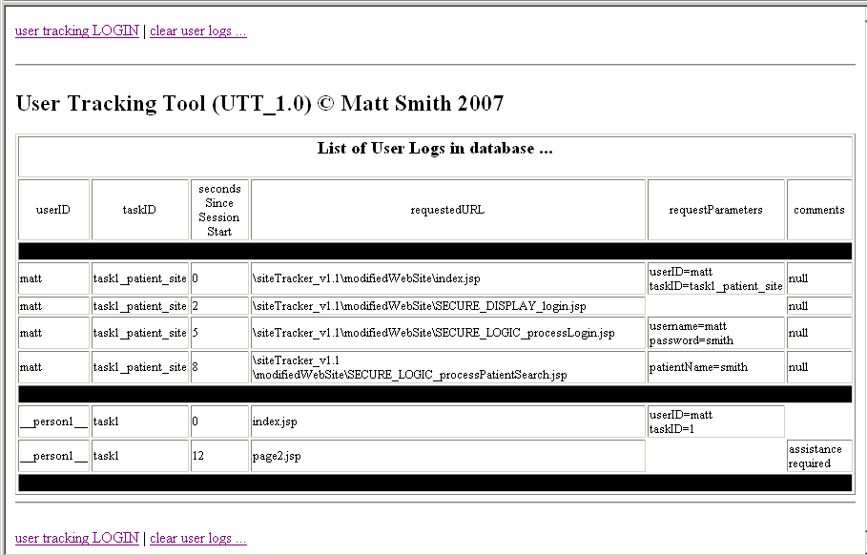

Figure: Screen shot of user logs for test with patientBeanTest website (and defaut __person1__ test data)

